КОММУТАЦИОННЫЕ КНОПКИ
Условное обозначение:  Пример: PBS-10B-2  PBS - тип  10 - серия  В - схема коммутации:  A ON - 0FF открытый и закрытый тип с фиксацией  B OFF - (ON) открытый тип без фиксации  C ON - (OFF) открытый тип без фиксации  2 - вариант исполнения | Технические характеристики:  Номинальные значения:  3А 125 В / 1А 250 В пер.тока  Контактное сопротивление:  20 МОм макс.  Сопротивление изоляции:  100Moм мин.( 500В пост.тока)  Электрическая прочность диэлектрика:  1000В пер.тока в течении 1 минуты  Электрический ресурс:  20 000 циклов

PBS-10B PUSH ON  AC 125V 3A AC250V 1A  (PLATIC ROD) | 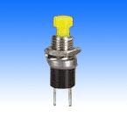 | 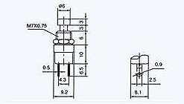

PBS-10B-2 PUSH ON  PBS-10C-2 PUSH OFF  AC 125V 3A AC250V 1A  (META2 ROD) | 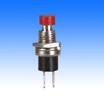 | 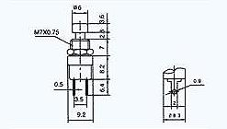

PBS-11A PUSH ON/PUSH OFF  PBS-11B PUSH ON  PBS-11C PUSH OFF  AC 125V 3A AC250V 1A | 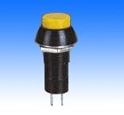 | 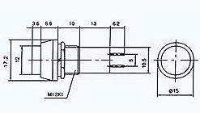

PBS-12A PUSH ON/PUSH OFF  PBS-12B PUSH ON  PBS-12C PUSH OFF  AC 125V 3A AC250V 1A | 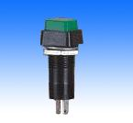 | 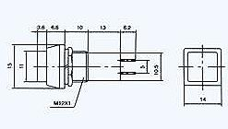

PBS-13B OFF-(ON)  PBS-13C ON-(OFF)  8A 125VAC;4A 250VA | 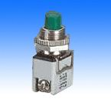 | 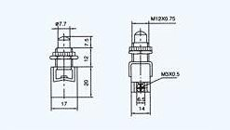

PBS-14A PUSH ON/PUSH OFF  PBS-14B PUSH ON  PBS-14C PUSH OFF  3A 125V 1A250AV | 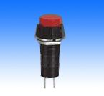 | 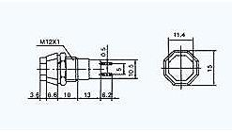

PBS-15B PUSH ON  PBS-15C PUSH OFF  3A 125V 1A250AV | 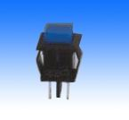 | 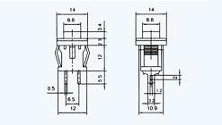

PBS-16A PUSH ON/PUSH OFF  PBS-16B PUSH ON  PBS-16C PUSH OFF  4A 125VAC 2A 250VAC | 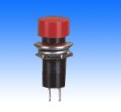 | 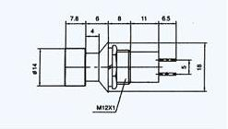

PBS-17A ON-OFF  4A 125VAC 2A 250VAC | 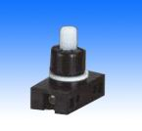 | 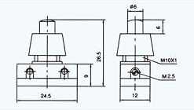

PBS-17A-2 ON-OFF  4A 125VAC 2A 250VAC | 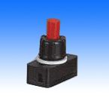 | 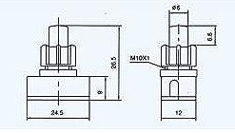

PBS-20A-2 ON-OFF  PBS-20B-2 OFF-(ON) | 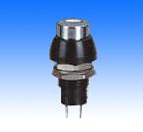 | 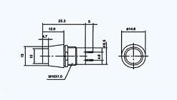

PBS-20A- ON-OFF  PBS-20B- OFF-(ON) | 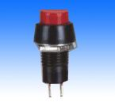 | 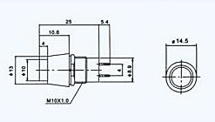

PBS-21A ON-OFF  PBS-21B OFF-(ON) | 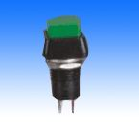 | 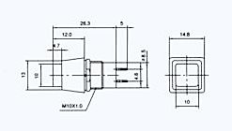

PBS-22A ON-OFF  PBS-22B OFF-(ON) | 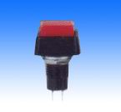 | 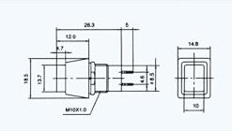

PBS-23B OFF-ON | 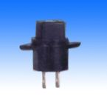 | 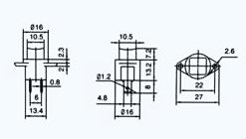

PBS-24-102 ON-ON  PBS-24-112 ON-(ON)  4A 125V 2A 250VAC  SPDT 3P | 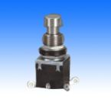 | 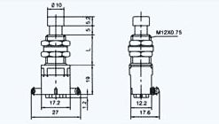

PBS-24-202 ON-ON  PBS-24-212 ON-(ON)  4A 125V 2A 250VAC | 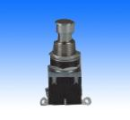 | 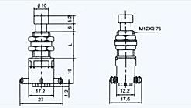

PBS-26B OFF-(ON)  PBS-26C ON-(OFF)  4A 125V 2A 250VAC | 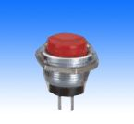 | 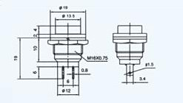

PBS-31B PUSH ON  3A/125VAC, 1A250VAC | 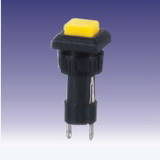 | 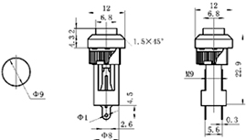

PBS-32B PUSH ON  3A/125VAC, 1A250VAC | 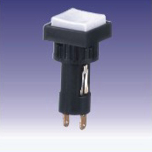 | 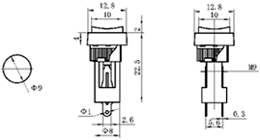

PBS-15A ON-OFF | 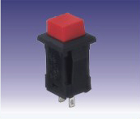 | 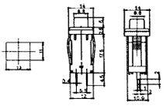

PBS-18B OFF-(ON)  25MA;50VAC or DC | 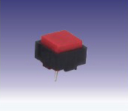 | 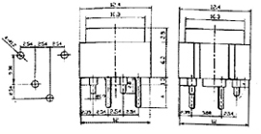

PBS-19B OFF-(ON)  PBS-19C ON(OFF)  5A/125VAC, 2.5A250VAC | 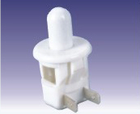 | 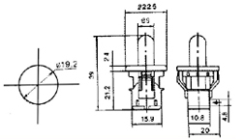

PBS-19B-3 OFF(ON)  PBS-19C-3 ON(OFF)  5A15VAC;2.5A 250VAC | 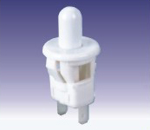 | 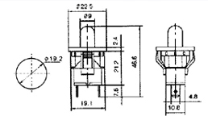

PBS-28B OFF-(ON)  4A125VAC;2A250VAC | 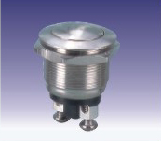 | 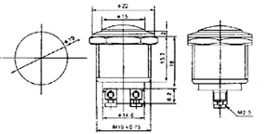

PBS-28B-2 OFF-(ON)  4A125VAC;2A250VAC | 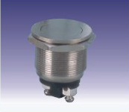 | 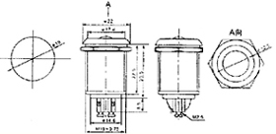

PBS-28B-3 OFF-(ON)  4A125VAC;2A250VAC | 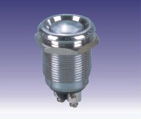 | 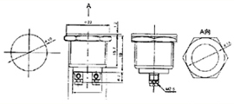

PBS-29B OFF-(ON) | 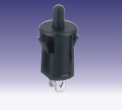 | 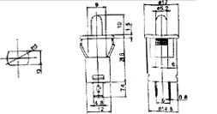

PBS-30B OFF-(ON) | 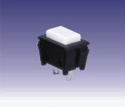 | 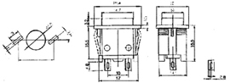

PBS-32B OFF-(ON)  10A125VAC;6A250VAC | 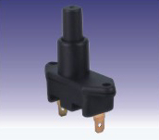 | 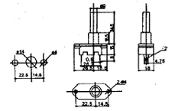

PBS-33B OFF-(ON) | 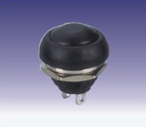 | 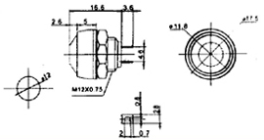

PBS-34B OFF-(ON)  10A 125VAC;6A 250VAC | 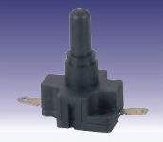 | 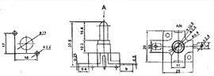

LS-01  LAMP SOCKET Ўй9.2 | 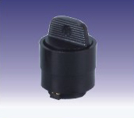 | 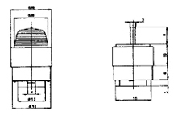

PBS-24-202P ON-ON  PBS-24-212P ON-(ON)  4A 125VAC;2A250VAC  DPDT 6P  (PC TERMINAL)  L=(14.2 11.8 9.8) | 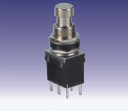 | 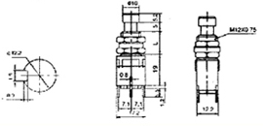

PBS-24B-2 OFF-ON  PBS-24C-2 ON-(OFF)  10A 125VAC;6A 250VAC  SPST 2P | 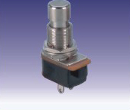 | 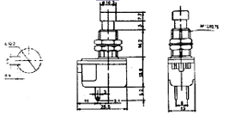

RLS-202-D1 ON-ON  RSL-212-D1 ON-(ON)  RLS-203-D1 ON-OFF-ON  RLS-213-D1 ON-OFF-(ON)  RLS-223-D1 (ON)-OFF-(ON)  DPDT 6P | 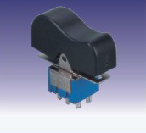 | 